Image to Image Mappings

Homographies

A homography is a 2D projection that maps points in one plane to another (while preserving the points)
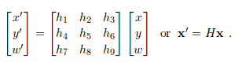

We usually want w to be 1, by convention, so we normalize the points we want to project



affine trasnformation:
preserves w = 1 and can't represent as strong deformations as full projective transformation

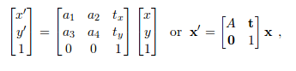
similarity transformation:
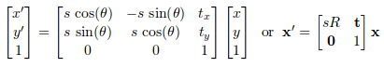

Rigid transformation that includes scale changes (can change scale). The scalar s specifies scaling, R is a rotation of angle theta. With s = 1, distances are preserved, and it is then a rigid transformation

Direct linear transformation algorithm

